-Shashank Gubba

1.

In the above picture we have found the required beta values for the regression model and the adjusted r2 score as well, which is as stated below

Adjusted r2 score = 0.8131284

2.

b) As per the output, optimum number of shops is 5 as we can see maximum profits. When the number of shops are increasing after 5 we can see a gradual decrease in the profits.

c) A scatter plot is plotted and is show in the above picture. The code for scatter plot is as follows

plt.title('No. of shops vs. Profit')

plt.scatter(shop,profit)

plt.xlabel('Number of shops')

plt.ylabel('Total profit')

plt.show()

d)

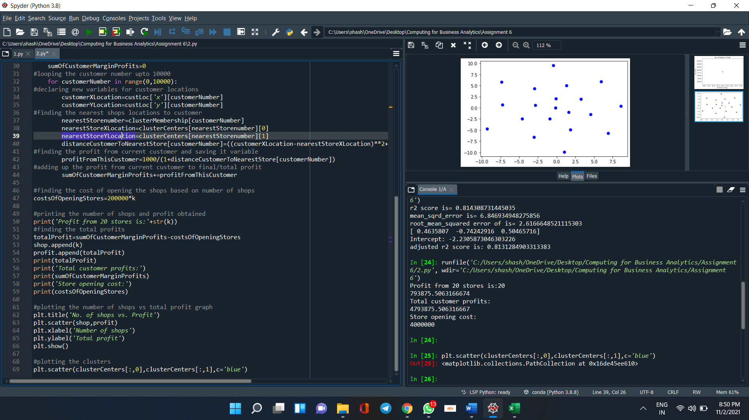

Scatter plot for the clusters is plotted in the above picture.

e) If the cost of opening each store is increased to $500,000 same number of stores is suggested but as the cost of opening the stores increases the marginal profit decreases the more when compared to the previous case.